To lay a robust foundation for the Institute to reach its Zenith.

* Achieving academic excellence through rigorous teaching, learning and evaluation practices.
* To develop an ability to apply knowledge of basic science and Mathematics to excel in the field of Engineering.
* To provide salutary environment for the betterment of faculty and the students.

## Branch: CSE and IT Subject: Advanced Chemistry

**Unit-3**

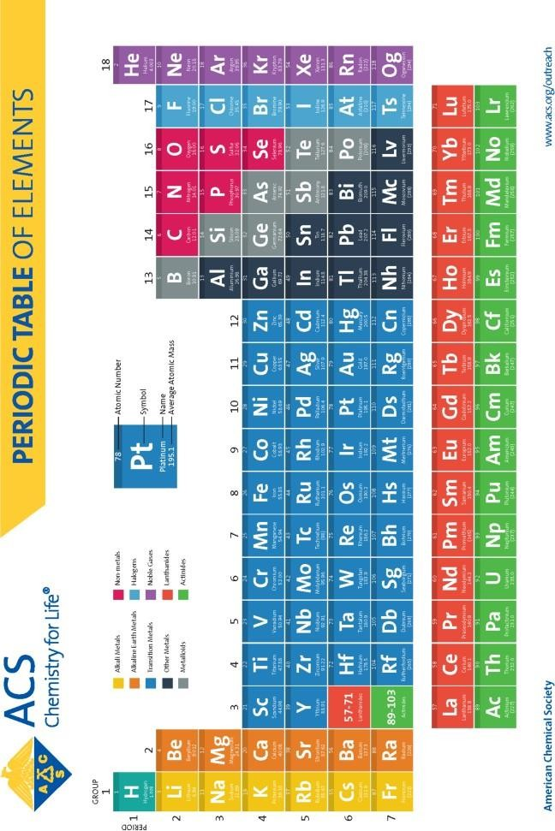

To lay a robust foundation for the Institute to reach its Zenith.

* Achieving academic excellence through rigorous teaching, learning and evaluation practices.
* To develop an ability to apply knowledge of basic science and Mathematics to excel in the field of Engineering.
* To provide salutary environment for the betterment of faculty and the students.

Contents

**Some of the Theories for Classification of Elements Modern Periodic Table**

**Atomic Radius**

**Ionization Energy (ionization potential)**

**Electron Affinity Electronegativity**

**Summary of Periodic Trends Penetration & Shielding**

Orbital Penetration

**Shielding**

Periodic Trends Due to Penetration and Shielding

**Polarizability**

**Polarization Power**

**Periodic Trends of the Polarizing power of cations Periodic Trends of Polarizability of Anions Oxidation State**

**Coordination Number**

**Hard and Soft Acids and Bases (HSAB) Principle**

To lay a robust foundation for the Institute to reach its Zenith.

* Achieving academic excellence through rigorous teaching, learning and evaluation practices.
* To develop an ability to apply knowledge of basic science and Mathematics to excel in the field of Engineering.
* To provide salutary environment for the betterment of faculty and the students.

**Some of the Theories for Classification of Elements**

* + **Prout’s Hypothesis**

First of all, came the Prout’s Hypothesis. Devised in the year 1815, hydrogen was regarded as the ‘central’ element around which all other atoms were made.

* + **Dobereiner’s Triads**

This theory came to light in the year 1829. According to the theory, the classification was made in such a way that each group consisted of three elements such that they owned the same properties. Also, in each case, the atomic weight of the middle element is supposed to be the arithmetic mean of the other two elements.

* + - **Newland’s Octaves**

Also known as the Law of Octaves, this theory was suggested in the year 1864. Newland suggested that elements should be arranged in order of increasing atomic masses. After such arrangement, every eighth element in the arrangement would have same properties as the first element in the arrangement, which follows the order of musical notes.

* + - **Lother Meyer’s Atomic Volume Curve**

The law came in the year 1869 and expressed the existing elements in the form of a curve between the atomic mass of the element and atomic volume. As per this theory, Lother concluded that all elements which hold the same properties came to occupy the same position on the curve.

* + **Mendeleev’s Periodic Table**

At the time of Mendeleef, only 63 elements had been discovered. He deduced that the physical and chemical properties are a periodic function of their atomic masses. Therefore, Mendeleev presented a systematic way to study existing elements.

To lay a robust foundation for the Institute to reach its Zenith.

* Achieving academic excellence through rigorous teaching, learning and evaluation practices.
* To develop an ability to apply knowledge of basic science and Mathematics to excel in the field of Engineering.
* To provide salutary environment for the betterment of faculty and the students.

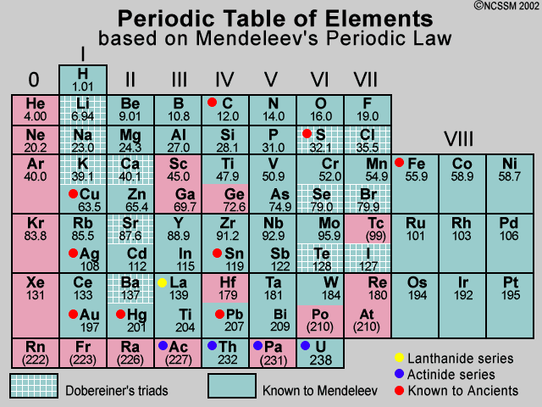

To lay a robust foundation for the Institute to reach its Zenith.

* Achieving academic excellence through rigorous teaching, learning and evaluation practices.
* To develop an ability to apply knowledge of basic science and Mathematics to excel in the field of Engineering.
* To provide salutary environment for the betterment of faculty and the students.

## Modern Periodic Table

In the beginning of the 19th century, a British physicist named ***Henry Moseley*** said that the elements will show periodicity if they are arranged in an order of increasing atomic numbers instead of atomic masses. He believed that the **characteristics of elements are based on their atomic numbers not on their atomic masses.**

Characteristic features of the modern periodic table

* + Elements are placed in the increasing order of atomic numbers.
  + There are seven horizontal rows of elements called 7 periods and 18 vertical columns of elements that are called groups. So, there are 18 groups in the modern periodic table that are numbered from 1 to 18.
  + There is a definite difference in the atomic number of elements in a group, which is 8, 18, and 32.
  + Elements are arranged in periods on the basis of number of energy shells in their atoms.
  + First period is the shortest period as it contains only two elements that include Hydrogen (H) and Helium (He).
  + The sixth period is the longest period of the modern periodic table.
  + The seventh period is still not complete.
  + The elements that belong to 1, 2, 13, 14, 15, 16, and 17 are known as representative or normal elements.
  + Elements from group 3 to 12 are known as transition elements.
  + The inert or noble gases are placed in group 18.
  + The f-block consists of two series of elements which are lanthanide and actinide series. The elements of these series or f-block are called rare earth elements or inner transition elements.

To lay a robust foundation for the Institute to reach its Zenith.

* Achieving academic excellence through rigorous teaching, learning and evaluation practices.
* To develop an ability to apply knowledge of basic science and Mathematics to excel in the field of Engineering.
* To provide salutary environment for the betterment of faculty and the students.
  + The elements of group 1 are called alkali metals; of group 2 are called alkaline earth metals; of group 16 are called chalcogens; of group 17 are called halogens and elements of group 18 are called noble gases.
  + As we go down a group, the number of shells increases. For example, in the first group hydrogen (H) has one shell, Lithium (Li) has two shells, and sodium (Na) has three shells and so on. However, the valence electrons in the outer shell of all elements in a group as we move down a group remains the same.
  + The valence shell electrons in the valence or last shell of elements increases by one with each step as we move from left to right in a period.

To lay a robust foundation for the Institute to reach its Zenith.

* Achieving academic excellence through rigorous teaching, learning and evaluation practices.
* To develop an ability to apply knowledge of basic science and Mathematics to excel in the field of Engineering.
* To provide salutary environment for the betterment of faculty and the students.

# Periodic Properties of the Elements

The elements in the periodic table are arranged in order of increasing atomic number. All of these elements display several other trends and we can use the periodic law and table formation to predict their chemical, physical, and atomic properties. Understanding these trends is done by analyzing the elements electron configuration; all elements prefer an octet formation and will gain or lose electrons to form that stable configuration.

### AtomicRadius

We can never determine the atomic radius of an atom because there is never a zero probability of finding an electron, and thus never a distinct boundary to the atom. All that we can measure is the distance between two nuclei (internuclear distance). **A covalent radius** is one-half the distance between the nuclei of two identical atoms. **An ionic radius** is one-half the distance between the nuclei of two ions in an ionic bond. The distance must be apportioned for the smaller cation and larger anion. **A metallic radius** is one-half the distance between the nuclei of two adjacent atoms in a crystalline structure. The noble gases are left out of the trends in atomic radii because there is great debate over the experimental values of their atomic radii.

The SI units for measuring atomic radii are the nanometer (nm) and the picometer (pm). **1 nm = 1 X 10-9 m; 1 pm = 1 X 10-12 m.**

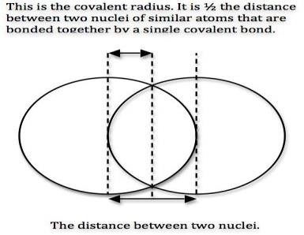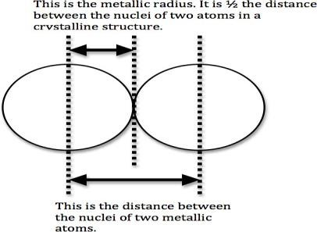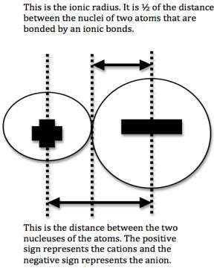

*Provided courtesy of Jessica Thornton (UCD*)

To lay a robust foundation for the Institute to reach its Zenith.

* + Achieving academic excellence through rigorous teaching, learning and evaluation practices.
  + To develop an ability to apply knowledge of basic science and Mathematics to excel in the field of Engineering.
  + To provide salutary environment for the betterment of faculty and the students.

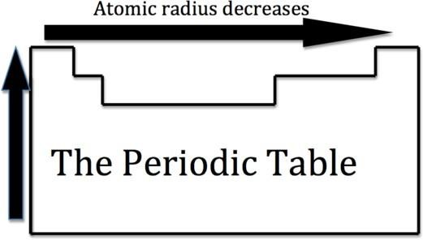Now we are ready to describe the atomic radius trend in the periodic table. The atomic number increases moving left to right across a period and subsequently so does the effective nuclear charge. Therefore, moving left to right across a period the nucleus has a greater pull on the outer electrons and the atomic radii decreases. Moving down a group in the

periodic table, the number of filled electron shells increases. In a group, the valence electrons keep the same effective nuclear charge, but now the orbitals are farther from the nucleus. Therefore, the nucleus has less of a pull on the outer electrons

and the atomic radii are larger.

We can now use these concept to explain the atomic radius differences of cations and anions. A cation is an atom that has lost one of its outer electrons. Cations have a smaller radius than the atom that they were formed from. With the loss of an electron, the positive nuclear charge out powers the negative charge that the electrons exert. Therefore, the positive nucleus pulls the electrons tighter and the radius is smaller. An anion is an atom that has gained an outer electron. Anions have a greater radius than the atom that they were formed from. The gain of an electron does not alter the nuclear charge, but the addition of an electron causes a decrease in the effective nuclear charge. Therefore, the electrons are held more loosely and the atomic radius is increased.

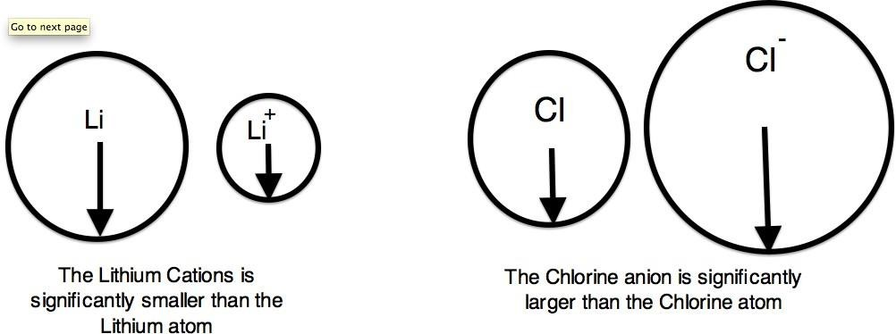

To lay a robust foundation for the Institute to reach its Zenith.

* + Achieving academic excellence through rigorous teaching, learning and evaluation practices.
  + To develop an ability to apply knowledge of basic science and Mathematics to excel in the field of Engineering.
  + To provide salutary environment for the betterment of faculty and the students.

### Ionization Energy (ionization potential)

Ionization energy (I.E. or I) is the energy required to completely remove an electron from a gaseous atom or ion. The Ionization Energy is always positive.

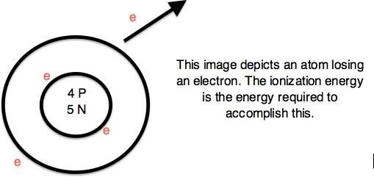

The energy required to remove one valence electron is the first ionization energy, the second ionization energy is the energy required to remove a second valence electron, and so on.

To lay a robust foundation for the Institute to reach its Zenith.

* + Achieving academic excellence through rigorous teaching, learning and evaluation practices.
  + To develop an ability to apply knowledge of basic science and Mathematics to excel in the field of Engineering.
  + To provide salutary environment for the betterment of faculty and the students.

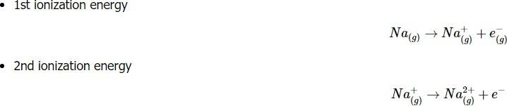

Ionization energies increase relative to high effective charge. The highest ionization energies are the noble gases because they all have high effective charge due to their octet formation and require a high amount of energy to destroy that stable configuration. The highest amount of energy required occurs with the elements in the upper right hand corner. Additionally, elements in the left corner have a low ionization energy because losing an electron allows them to have the noble gas configuration. Therefore, it requires less energy to remove one of their valence electrons.

Ionization Energies increase going left to right across a period and increase going up a group. As you go up a group, the ionization energy increases, because there are less electron shielding the outer electrons from the pull of the nucleus. Therefore, it requires more energy to out power the nucleus and remove an electron. As we move across the periodic table from left to right, the ionization energy increases, due to the effective nuclear charge increasing. This is because the larger the effective nuclear charge, the stronger the nucleus is holding onto the electron and the more energy it takes to release an electron.

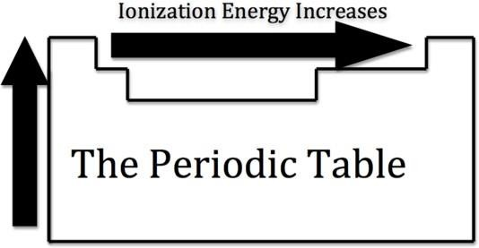

The ionization energy is only a general rule. There are some instances when this trend does not prove to be correct. These can typically be explained by their electron configuration. For example, Magnesium has a higher ionization energy than Aluminum. Magnesium has an electron configuration of [Ne]3s2. Magnesium has a

To lay a robust foundation for the Institute to reach its Zenith.

* + Achieving academic excellence through rigorous teaching, learning and evaluation practices.
  + To develop an ability to apply knowledge of basic science and Mathematics to excel in the field of Engineering.
  + To provide salutary environment for the betterment of faculty and the students.

high ionization energy because it has a filled 3s orbital and it requires a higher amount of energy to take an electron from the filled orbital.

**Electron Affinity**

Electron affinity (E.A.) is the energy change that occurs when an electron is added to a gaseous atom. Electron affinity can further be defined as the enthalpy change that results from the addition of an electron to a gaseous atom. It can be either positive or negative value. The greater the negative value, the more stable the anion is.

To lay a robust foundation for the Institute to reach its Zenith.

* + Achieving academic excellence through rigorous teaching, learning and evaluation practices.
  + To develop an ability to apply knowledge of basic science and Mathematics to excel in the field of Engineering.
  + To provide salutary environment for the betterment of faculty and the students.
    - (Exothermic) The electron affinity is positive

X(g) + e−→X− +Energy

* + - (Endothermic) The electron affinity is negative

X(g)+e−+Energy→X−

It is more difficult to come up with trends that describe the electron affinity. Generally, the elements on the right side of the periodic table will have large negative electron affinity. The electron affinities will become less negative as you go from the top to the bottom of the periodic table. However, Nitrogen, Oxygen, and Fluorine do not follow this trend. The noble gas electron configuration will be close to zero because they will not easily gain electrons.

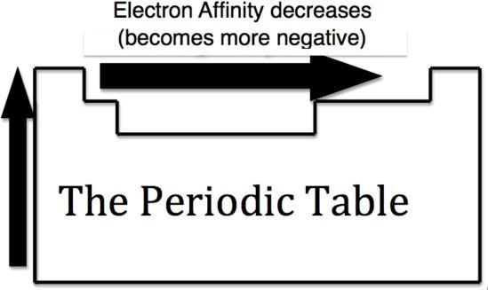

## Electronegativity

Electronegativity is the measurement of an atom to compete for electrons in a bond. The higher the electronegativity, the greater its ability to gain electrons in a bond. Electronegativity will be important when we later determine polar and nonpolar molecules. Electronegativity is related with ionization energy and electron affinity. Electrons with low ionization energies have low electronegativities because their nuclei do not exert a strong attractive force on electrons. Elements with high ionization energies have high electronegativities due to the strong pull exerted by the positive nucleus on the negative electrons. Therefore the electronegativity increases from bottom to top and from left to right.

To lay a robust foundation for the Institute to reach its Zenith.

* + Achieving academic excellence through rigorous teaching, learning and evaluation practices.
  + To develop an ability to apply knowledge of basic science and Mathematics to excel in the field of Engineering.
  + To provide salutary environment for the betterment of faculty and the students.

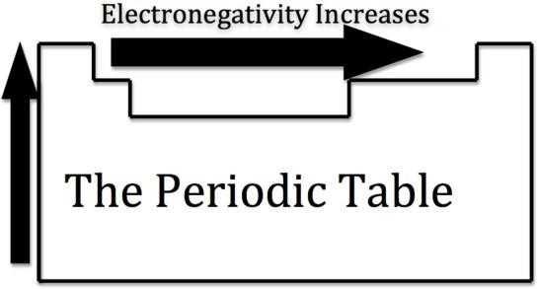

To lay a robust foundation for the Institute to reach its Zenith.

* + Achieving academic excellence through rigorous teaching, learning and evaluation practices.
  + To develop an ability to apply knowledge of basic science and Mathematics to excel in the field of Engineering.
  + To provide salutary environment for the betterment of faculty and the students.

## Summary of Periodic Trends

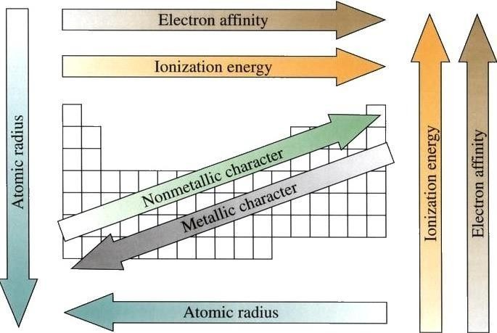

To lay a robust foundation for the Institute to reach its Zenith.

* + Achieving academic excellence through rigorous teaching, learning and evaluation practices.
  + To develop an ability to apply knowledge of basic science and Mathematics to excel in the field of Engineering.
  + To provide salutary environment for the betterment of faculty and the students.

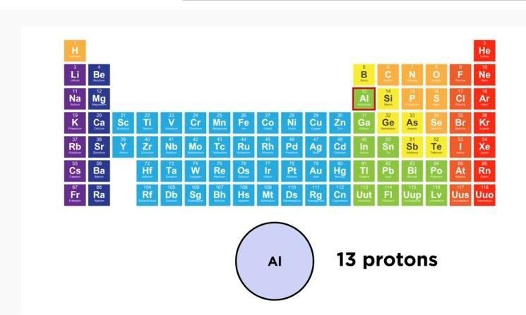

To lay a robust foundation for the Institute to reach its Zenith.

* + Achieving academic excellence through rigorous teaching, learning and evaluation practices.
  + To develop an ability to apply knowledge of basic science and Mathematics to excel in the field of Engineering.
  + To provide salutary environment for the betterment of faculty and the students.

**Penetration & Shielding**

Electrons are negatively charged and are pulled pretty close to each other by their attraction to the positive charge of a nucleus. The electrons are attracted to the nucleus at the same time as electrons repel each other. The balance between attractive and repulsive forces results in *shielding*. The orbital (*n*) and subshell (*ml*) define how close an electron can approach the nucleus. The ability of an electron to get close to the nucleus is *penetration*.

The force that an electron feels is dependent on the distance from the nearest charge (i.e., an electron, usually with bigger atoms and on the outer shells) and the amount of charge. More distance between the charges will result in less force, and more charge will have more force of attraction or repulsion.

In the simplest case, every electron in an atom would feel the same amount of "pull" from the nucleus. For example, in Li, all three electrons might "feel" the +3 charge from the nucleus. However, this is not the case when observing atomic behavior. When considering the core electrons (or the electrons closest to the nucleus), the nuclear charge "felt" by the electrons (*Effective Nuclear Charge* (Zeff)) is close to the actual nuclear charge. As you proceed from the core electrons to the outer valence electrons, Zeff falls significantly. This is because of *shielding*, or simply the electrons closest to the nucleus decrease the amount of nuclear charge affecting the outer electrons. Shielding is caused by the combination of partial neutralization of nuclear charge by core electrons, and by electron-electron repulsion.

The amount of charge felt by an electron depends on its distance from the nucleus. The closer an electron comes to the nucleus, or the more it *penetrates*, the stronger its attraction to the nucleus. Core electrons *penetrate* more and feel more of the nucleus than the other electrons.



To lay a robust foundation for the Institute to reach its Zenith.

* + Achieving academic excellence through rigorous teaching, learning and evaluation practices.
  + To develop an ability to apply knowledge of basic science and Mathematics to excel in the field of Engineering.
  + To provide salutary environment for the betterment of faculty and the students.

with

* + - Z is the charge of the nucleus (i.e., number of protons)
    - e is the charge of an electron or proton
    - r is the radius, or distance between the proton and the electron

•

Orbital Penetration

Penetration describes the proximity to which an electron can approach to the nucleus. In a multi-electron system, electron penetration is defined by an electron's relative electron density (probability density) near the nucleus of an atom. Electrons in different orbitals have different wave functions and therefore different radial distributions and probabilities (defined by quantum numbers *n* and *ml* around the nucleus). In other words, penetration depends on the shell (*n*) and subshell (*ml)*.

For example, we see that since a 2s electron has more electron density near the nucleus than a 2p electron, it is penetrating the nucleus of the atom more than the 2p electron. The penetration power of an electron, in a multi-electron atom, is dependent on the values of both the shell and subshell.

Within the same shell value (*n*), the penetrating power of an electron follows this trend in subshells (*ml*):

s>p>d>f

And for different values of shell (n) and subshell (l), penetrating power of an electron follows this trend:

1s>2s>2p>3s>3p>4s>3d>4p>5s>4d>5p>6s>4f....

and the energy of an electron for each shell and subshell goes as follows...

1s<2s<2p<3s<3p<4s<3d<4p....

The electron probability density for s-orbitals is highest in the centre of the orbital, or at the nucleus. If we imagine a dartboard that represents the circular shape of the s-

To lay a robust foundation for the Institute to reach its Zenith.

* + Achieving academic excellence through rigorous teaching, learning and evaluation practices.
  + To develop an ability to apply knowledge of basic science and Mathematics to excel in the field of Engineering.
  + To provide salutary environment for the betterment of faculty and the students.

orbital and if the darts landed in correlation to the probability to where and electron would be found, the greatest dart density would be at the 50 points region but most of the darts would be at the 30 point region. When considering the 1s-orbital, the spherical shell of 53 pm is represented by the 30 point ring.

Electrons which experience greater penetration experience stronger attraction to the nucleus, less shielding, and therefore experience a larger *Effective Nuclear Charge* (Zeff), but shield other electrons more effectively.

## Shielding

An atom (assuming its atomic number is greater than 2) has core electrons that are extremely attracted to the nucleus in the middle of the atom. However the number of protons in the nucleus are never equal to the number of core electrons (relatively) adjacent to the nucleus. The number of protons increase by one across the periodic table, but the number of core electrons change by periods. The first period has no core electrons, the second has 2, the third has 10, and etc. This number is not equal to the number of protons. So that means that the core electrons feel a stronger pull towards the nucleus than any other electron within the system. The valence electrons are farther out from the nucleus, so they experience a smaller force of attraction.

Shielding refers to the core electrons repelling the outer rings and thus lowering the 1:1 ratio. Hence, the nucleus has "less grip" on the outer electrons and are shielded from them. Electrons that have greater penetration can get closer to the nucleus and effectively block out the charge from electrons that have less proximity. For example, Zeff is calculated by subtracting the magnitude of shielding from the total nuclear charge. The value of Zeff will provide information on how much of a charge an electron actually experiences.

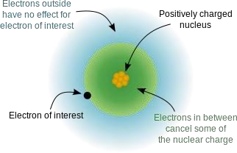

To lay a robust foundation for the Institute to reach its Zenith.

* + Achieving academic excellence through rigorous teaching, learning and evaluation practices.
  + To develop an ability to apply knowledge of basic science and Mathematics to excel in the field of Engineering.
  + To provide salutary environment for the betterment of faculty and the students.

Because the order of electron penetration from greatest to least is s, p, d, f; the order of the amount of shielding done is also in the order s, p, d, f.

Since the 2s electron has more density near the nucleus of an atom than a 2p electron, it is said to shield the 2p electron from the full effective charge of the nucleus. Therefore, the 2p electron feels a lesser effect of the positively charged nucleus of the atom due to the shielding ability of the electrons closer to the nucleus than itself, (i.e. 2s electron).

These electrons that are shielded from the full charge of the nucleus are said to experience an ***effective nuclear charge*** *(*Zeff)of the nucleus, which is some degree less than the full nuclear charge an electron would feel in a hydrogen atom or hydrogen like ions. The effective nuclear charge of an atom is given by the equation:

Zeff=Z−S

where.

* + - Z is the atomic number (number of protons in nucleus) and
    - S is the shielding constant

We can see from this equation that the effective nuclear charge of an atom increases as the number of protons in an atom increases. Therefore, as we go from left to right on the periodic table the effective nuclear charge of an atom increases in strength and holds the outer electrons closer and tighter to the nucleus. This phenomenon can explain the decrease in atomic radii we see as we go across the periodic table as electrons are held closer to the nucleus due to increase in number of protons and increase in effective nuclear charge.

To lay a robust foundation for the Institute to reach its Zenith.

* + Achieving academic excellence through rigorous teaching, learning and evaluation practices.
  + To develop an ability to apply knowledge of basic science and Mathematics to excel in the field of Engineering.
  + To provide salutary environment for the betterment of faculty and the students.

### Periodic Trends Due to Penetration and Shielding

* + - **Effective Nuclear Charge (**Zeff**):** The effective nuclear charge increases from left to right and increases from top to bottom on the periodic table.
    - **Atomic Radius:** The atomic radius decreases from left to right, and increases from top to bottom.
    - **Ionization Energies:** The ionization energies increase from left to right, and decrease from top to bottom.
    - **Electronegativity:** The electronegativity of the elements is highest near fluorine. In general, it increases from left to right and decreases from top to bottom.



# Polarizability

The ratio of the size of an ion to its charge is called **charge density.** Generally, positive ions have higher charge density and smaller size and negative ions have a large charge but low charge density (except F– and 0-2 ions). The ease with which the charge distribution in a molecule can be distorted by an external electric field is called

To lay a robust foundation for the Institute to reach its Zenith.

* + Achieving academic excellence through rigorous teaching, learning and evaluation practices.
  + To develop an ability to apply knowledge of basic science and Mathematics to excel in the field of Engineering.
  + To provide salutary environment for the betterment of faculty and the students.

its **polarizability.**

In general, larger molecules tend to have greater polarizabilities because they have a greater number of electrons and their electrons are further from the nuclei. When a cation approaches an anion closely, the net positive charge on the cation tends to attract the electron cloud of the anion, towards itself due to the electrostatic force of attraction existing between them. At the same time, the cation also tends to repel the positively charged nucleus of the anion.

To lay a robust foundation for the Institute to reach its Zenith.

* + Achieving academic excellence through rigorous teaching, learning and evaluation practices.
  + To develop an ability to apply knowledge of basic science and Mathematics to excel in the field of Engineering.
  + To provide salutary environment for the betterment of faculty and the students.

## Polarization Power

The combined effect of these two forces is that the *electron cloud of the anion no longer remains symmetrical but is bulged or elongated towards the cation.* This is called **distortion, deformation** or **polarization** of the anion by the cation and the anion is said to be **polarized.** The ability of a cation to polarize (or distort) a nearby anion is called its **polarization** ability or polarization power.

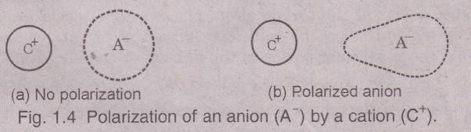

The cation is also polarized by the anion, but because the size of a cation is generally smaller than anion, the cation is polarized by the anion to a less extent i.e., the polarization of a cation by an anion is considered almost negligible in most cases.

## Periodic Trends of the Polarizing power of cations

* + - **In a period:** In moving from left to right in a period, the size of the cations decreases, and the positive charge increases. *Both these factors increase the polarizing power of the cations from left to right in a period.*
    - **In a group** On descending a group, the magnitude of positive charge remains in the same and hence it is the size of the cation alone which affects the magnitude of the polarizing power of the given cation. *On moving down a group the size of the cations increases and hence the polarizing power of the cation goes on decreasing.*

To lay a robust foundation for the Institute to reach its Zenith.

* + Achieving academic excellence through rigorous teaching, learning and evaluation practices.
  + To develop an ability to apply knowledge of basic science and Mathematics to excel in the field of Engineering.
  + To provide salutary environment for the betterment of faculty and the students.

## Periodic Trends of Polarizability of Anions

* + - **In a Period:** In moving from left to right in a period, both negative charge on the anions and their size decrease. Both these factors decrease the polarizability of the anions by given cations from left to right in a period of the periodic table.

 **In a Group:** On descending a group, the magnitude of negative charge on the anions remains the same and hence it is the size of the anion alone which affects the magnitude of the polarizability of a given anion. *On moving down a group thesize of the anions increases and hence the polarizability* of the anions also goes on increasing.

# Oxidation State

The oxidation state of an atom is equal to the total number of electrons which have been removed from an element (producing a positive oxidation state) or added to an element (producing a negative oxidation state) to reach its present state.

* **Oxidation involves an increase in oxidation state**
  + **Reduction involves a decrease in oxidation state**

The more electronegative element in a substance is assigned a negative oxidation state. The less electronegative element is assigned a positive oxidation state. Remember that electronegativity is greatest at the top-right of the periodic table and decreases toward the bottom-left.

Coordination Number

The coordination number of an element refers to the number of ligands or elements that can fit around a central atom. A ligand is an ion or molecule that binds to a central metal atom. In a molecule, the coordination number is equal to the number of surrounding atoms. Coordination number changes down a group, because size

To lay a robust foundation for the Institute to reach its Zenith.

* Achieving academic excellence through rigorous teaching, learning and evaluation practices.
* To develop an ability to apply knowledge of basic science and Mathematics to excel in the field of Engineering.
* To provide salutary environment for the betterment of faculty and the students.

changes down a group. Size increases down a group, so the farther down a group an element is, the more ligands can fit around it because of its bigger size, and the larger its coordination number will be.

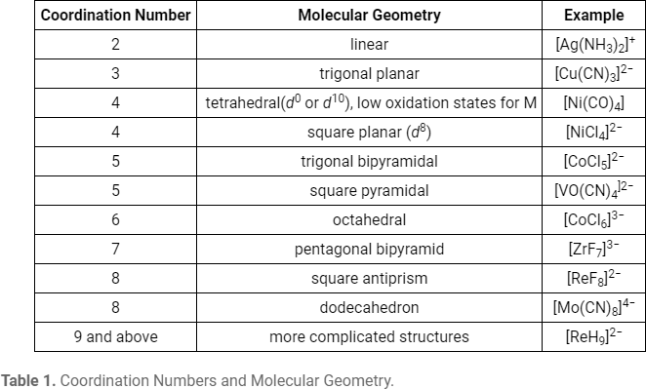

|  |  |
| --- | --- |
| **Vision** | **Mission** |
| To lay a robust foundation for the Institute to reach its Zenith. | * Achieving academic excellence through rigorous teaching, learning and evaluation practices. * To develop an ability to apply knowledge of basic science and Mathematics to excel in the field of Engineering. * To provide salutary environment for the betterment of faculty and the students. |

# Hard and Soft Acids and Bases (HSAB) Principle

**Hard and Soft Acids and Bases (HSAB) Principle** is a qualitative concept introduced by Ralph Pearson to explain the stability of metal complexes and the mechanisms of their reactions..

According to HSAB principle, the Lewis acids and bases can be further divided into hard or soft or borderline types.

**Hard Lewis acids** are characterized by small ionic radii, high positive charge, strongly solvated, empty orbitals in the valence shell and with high energy LUMOs.

**Soft Lewis acids** are characterized by large ionic radii, low positive charge, completely filled atomic orbitals and with low energy LUMOs.

**Hard Lewis bases** are characterized by small ionic radii, strongly solvated, highly electronegative, weakly polarizable and with high energy HOMOs.

**Soft Lewis bases** are characterized by large ionic radii, intermediate electronegativity, highly polarizable and with low energy HOMOs.

The **Borderline** Lewis acids and bases have intermediate properties.

Remember that it is not necessary for Lewis acid or base to possess all the properties to be classified as hard or soft or borderline.

***In short, Hard acids and bases are small and non-polarizable, whereas Soft acids and bases are larger and more polarizable.***

25

|  |  |
| --- | --- |
| **Vision** | **Mission** |
| To lay a robust foundation for the Institute to reach its Zenith. | * Achieving academic excellence through rigorous teaching, learning and evaluation practices. * To develop an ability to apply knowledge of basic science and Mathematics to excel in the field of Engineering. * To provide salutary environment for the betterment of faculty and the students. |

***According to HSAB concept, hard acids prefer binding to the hard bases to give ionic complexes, whereas the soft acids prefer binding to soft bases to give covalent complex***

26